

August 9, 2026 | 10:00am
Eleventh Sunday after Pentecost

God Gathers Us
Prelude Tina Wang
Welcome & Announcements Duty elder -Ron Richardson
Call to Worship The Rev. Thomas Kim
*Hymn Holy, Holy, Holy #299
Prayers of Confession & Assurance of God's grace

God’s Word Transforms Us
Story time The Rev. Thomas Kim
Musical interlude
Responsive reading Psalm 19:7-11(NRSV) – Lydia Akuffo
Old Testament Reading Isaiah 55:10-11
New Testament Reading 2 Timothy 3: 14-17 – Joshua Bleick
Gospel reading John 20: 30-31,21:25
Message From Words to Life
The Rev. Thomas Kim
*Hymn Thy word is a lamp upon my feet #496

We respond, God hears our Prayers
Offering
*Doxology / Prayer Praise God from who all blessings flow #79
Sharing Youssef Al-Khodor
Prayers of thanksgiving and intercession
followed by the Lord’s Prayer (in unison) [sins/sin against us]

God Sends Us
*Song Take time to be holy #638
*Benediction Go now in peace
*Hymn Amen #780
Postlude Tina Wang
*Please stand in body or in spirit



ARE YOU VISITING OR NEW TO CALVIN?
If today is your first visit to Calvin or if you are new and want to learn more about Christianity or about church activities, please fill out the BLUE CARD found in the PEW RACK. Calvin is here to help you on your faith journey – we are a place where Jesus is WORSHIPPED, LIVED and SHARED and we are so glad you have come.

QUIET BAGS & CLIPBOARDS FOR CHILDREN
Just a reminder to parents that Quiet Bags and Clipboards with colouring pages are available as there is no Kid Connect Class during August. Bags can be retrieved from the back of the sanctuary. Please return them to the box at the end of the service. Thank you.

This week at Calvin: Aug 9th – Aug 15th

Sat | Pancake Breakfast hosted by the Men’s Group

Dates to remember

Aug 15th  Aug 30th | Pancake Breakfast hosted by the Men’s Group  Church Picnic @ the home of Frank & Julia

Thank You to our Volunteers this morning!

Greeter: Miriam Fleming
Coffee Hosts: Jo-Ann Kiss &Margaret Houtby

The flowers in the sanctuary are placed by Andy & Jo-Ann Kiss
Many thanks to Calvin Church members for Sean’s Memorial

Welcome, Soeun Yoo

We warmly welcome Soeun Yoo to Calvin Presbyterian Church.

Soeun is a Theological Field Education student from Vancouver School of Theology. As part of her Master of Divinity program, she will be with us until the end of November, actively participating in various areas of church life, including preaching, worship leadership, and other ministry programs.

Soeun grew up in Japan as an ethnic Korean and came to Canada to study theology. She was drawn to theological studies through encounters with the writings of C. S. Lewis, Dietrich Bonhoeffer, and other Christian thinkers during her undergraduate years, when she majored in Horticulture. She is especially interested in the contextualization of the Christian gospel.

Among her ministry and work experiences, Soeun considers her part-time ministry to be the most meaningful. She has also worked in translation, interpretation, and as a barista and server.

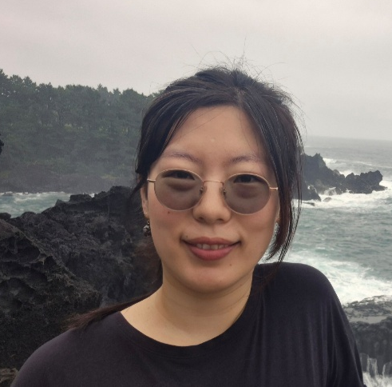
In her free time, Soeun enjoys road trips, psychology, long walks, public theology, and community outreach. She is grateful for the opportunity to learn alongside the congregation at Calvin Presbyterian Church and hopes to grow as a leader who cultivates vibrant, life-giving Christian communities.

Please join us in giving Soeun a warm Calvin welcome and in praying for her as she begins this season of learning and ministry among us.


THE MEN’S FELLOWSHIP GROUP IS INVITING YOU TO BREAKFAST
Mark your calendars for Saturday, August 15th beginning at 9:00am as the Men’s Fellowship Group prepare and serve a breakfast of pancakes, eggs, sausage, syrup and fresh cantaloupe from Jonathan’s garden. The invitation is open to everyone. Please sign-up on the clipboard located at the Information Desk so the men can plan accordingly.
Come celebrate summer!

ARE YOU ON PAR?
Have you ever considered PAR: Pre-Authorized Remittance?
Did you know we currently have 20 Families using PAR!
PAR enables you to give your offering intentionally, proportionally and faithfully all year long through an automatic monthly withdrawal from your bank account. Using PAR provides Calvin with financial stability, helping us focus on sharing the love of Christ. Need more information, pickup a PAR Brochure from the Information Table or speak with Marilyn Instant or Cathy Thomson.

TODAY DEVOTIONAL GUIDE
Copies of the September/October Guide are now available. You can pick up a copy from the Information Desk. Large prints are also available.

LET’S KEEP THE RED WAGON MOVING!!
Whenever we fill that red wagon with non-perishable food items – someone is thanking God and thanking us. Thanks, from your Food Bank Team: Mark, Cathie and Cameron!

JOSHUA HOUSE – Big Grey Bin
Remember that Joshua House is always in need of men’s clothing, toiletries, blankets and linens. Just drop the items in the big bin in the Gathering space. Thank you for your ongoing support!

CALVIN MUSIC ACADEMY
Calvin Music Academy, a non-profit organization, was created with a simple but meaningful purpose: to make the gift of music accessible and affordable for children and adults.
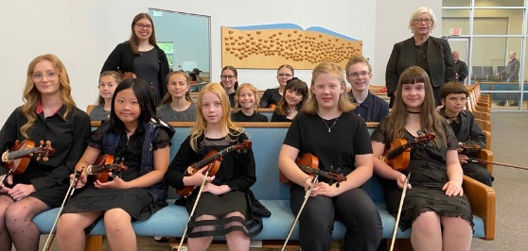
Through lessons in violin, ukulele, guitar and handbells, the academy gives students the chance to discover their abilities, grow in confidence, and experience the joy of making music. New classes begin the week of September 14th; classes fill up quickly. For more information, please check out our website at calvinmusic.ca or email Jo Blaak, Program Coordinator at joblaak@gmail.com

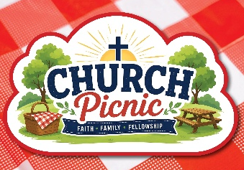
CHURCH PICNIC – August 30th immediately following Worship
All are invited to the home of Frank & Julia for an afternoon of summer fun and fellowship.
Calvin will provide hot dogs, salads and bottled water. Please bring additional beverages of your choice and a dessert to share, if you are able. This is a rain or shine event with cover plans already arranged in the event of precipitation. Please invite friends and family. Please RSVP on the clipboard located in the Gathering Space as this helps with planning. Transportation from Calvin Church will be available. Need the address? - please call the church office.

A WAY OF SERVING
Want to take an active part in Worship?
You can do it in two ways:
- Consider volunteering as a Scripture Reader. Speak to Don Blaak for more information or you can sign-up on the list located on the Information Desk.
- Offer to be a Greeter. A greeter welcomes worshippers as they enter the sanctuary, hands out bulletins, takes attendance and a few other small tasks. It’s a great way to meet new people and a simple way to be involved in the life, work and mission here at Calvin. It’s a great activity for families. Contact the church office if interested.

DID YOU KNOW?

Did you know that Ministers in The Presbyterian Church in Canada receive five weeks of vacation and two weeks of study leave/continuing education time each year
(and leave may be accumulated for up to five years)?

So far this year, Rev. Kim has taken two weeks of vacation—one week in April and one week in May. Session has agreed for him to use his two weeks of study leave and the remainder of his vacation this November, when he hopes to participate in a short-term mission among Karen refugee communities.

The BOOK NOOK
still rolls!

Lots to choose from in our Library and on our Rolling A-Frame!

Take a book home today!


SUPPORTING CALVIN
Want to support the ministries of Calvin? Consider doing it online via e-transfer. Use the email CalvinChurchDonation@gmail.com.
Be sure to include your name or envelope number.

The financial review has been completed for 2025. Nolan Baerg, CPA, stated the financial records are in order. The signed document is available in the office.

Pearl will be back in the office on Thursday August 13th and Friday August 14th.

CONTACT INFORMATION

Minister: The Rev. Thomas Kim 778-598-2214 worshipliveshare@gmail.com

Worship Coordinator: Don Blaak 604-866-3710
worshipcalvinchurch@gmail.com

Youth Connect: Maria Bitter
youthconnectcalvinchurch@gmail.com

Administrative Assistant: Pearl Overhill 604-859-6902
Church Office Hours: Wednesdays & Fridays 9:00am-2:00pm
officecalvinchurch@gmail.com

33911 Hazelwood Avenue, Abbotsford, BC V2S 7V2

Volunteers for next week, August 16th Worship:

Greeter: Jonathan Stevens
Coffee Hosts: Marilyn Instant & Miriam Fleming

CHECK US OUT ONLINE!
Join us for in-person worship or online.
Website: www.CalvinLife.ca

Facebook: Calvin Presbyterian Church Abbotsford

YouTube: Calvin Presbyterian Church Abbotsford

